IT 5434 Network Security Fundamentals
Lab Assignment 8 (L8)
60 points
Due: see due date under Dropbox on Folio
Prepared by Dr. Lei Chen
Student Name: Emmanuel Opara
SSL/TLS on Apache Web Server with Self-signed Digital Certificate
Secure Socket Layer/Transport Layer Security (SSL/TLS) is the standard for providing secure communication channel over public internet for many applications and services, such as banks’ websites. It requires the web server to have a digital certificate that contains its public key, which will be sent to the web client when the https webpage is visited. The server’s public key will be used by the client for encrypting a symmetric session key (generated by client and sent to the server encrypted; server uses its private key, paired with the public key, to decrypt and obtain the same session key). This symmetric session key will then be used for encrypting all data within the secure channel established. The cipher algorithm for using digital certificate and server public key is typically RSA, and the cipher algorithm for encrypting communication data using symmetric session key is typically AES.
Note: It is recommended to use the XAMPP environment in Windows for this lab. The following instructions are for the recommended setup environment. But you may choose to use Linux and XAMPP/LAMP environment. In that case, you will be responsible in finding and using the correct instructions. Make sure that all your screenshots are clear and large enough for grading.
- Download XAMPP (Apache + MySQL + PHP + Perl) – we tested older versions and version 7.3.3 worked well on Windows 7, 8 series and 10.
- Start your Apache server/service (on both ports 80 and 443, or ports that work) in XAMPP Control Panel.
  - Normally port #80 is used for http and port #443 is used for https. If these ports are not available (certain software like VMWare may create some problems here), you will receive error messages when starting Apache. In this case, click the “Config” button on the top (with a wrench icon), then go to Service and Port Settings. Change the default ports for Apache to 8080 (main port) and 8443 (SSL/TLS port) or some other ports that may be available. If the above configuration still cannot make it to work, then you have to edit the two configuration files (one for http and the other for https/ssl, search YouTube for guidance videos) to change the port numbers. Now instead of using port #80, your Apache will be using #8443 for https (and you need to specify the port number such as https://localhost:8443 in the URL in browser).
  - Paste your screenshot(s) of your XAMPP Control Panel below to show that your Apache is running with both non-secure and secure versions on two different ports.
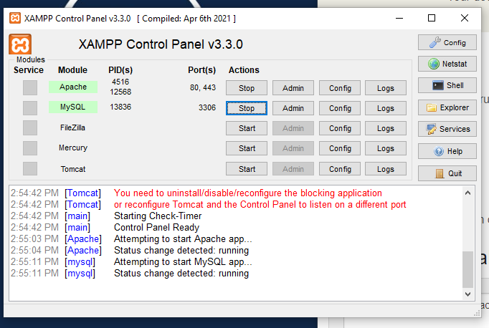
- Like a bank’s website, you want to have your own digital certificate generated and installed with your Apache server. The digital certificate will contain your public key to be sent to any client browser visiting your website. But the difference here is that you are going to create your self-signed digital certificate, which will NOT be signed/issued by a Certificate Authority like Verisign.
  - Before doing this, you will need to install OpenSSL. Go online, search, download and install Win32 OpenSSL v1.0.2g. Use the default settings for installation and remember the directory where you install it.
  - After installation, open command prompt (cmd) and see if you can run command “openssl”. If it says it cannot find the command, it means you will need to set the correct “path” parameter so that the OS will be able to find the openssl command. By default installation, your openssl command should be under “C:\OpenSSL-Win32\bin” (double check this on your own). Now go to Control Panel, then System and Security, then System, then Advanced system settings, then Advanced tab, then Environment Variables (depending your Windows version, this might be slightly different). Under “System variables”, find the “path” variable and edit it. Make sure to include “C:\OpenSSL-Win32\bin” in the path variable (so that the computer knows where to find the command and run it). Take a screenshot of your path parameter value and paste it below. Now click OK to set the path. Try to run “openssl” in a new command prompt. It should work this time.
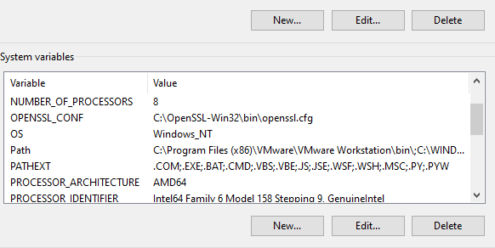
  - Go to your command prompt. Enter command “openssl req -x509 -sha256 -nodes -days 365 -newkey rsa:2048 -keyout server.key -out server.crt”. The following details are recommended for creating certificate: Country Name = “US”, State or Province Name = “Georgia”, Locality Name = Statesboro, Organization Name = “Georgia Southern University”, Organization Unit Name = “Information Technology”, Common Name = “server”, Email address = your_email_address. Then create a challenge password and keep it in mind (only in the case it asked for it). Now paste below a screenshot of your command prompt.
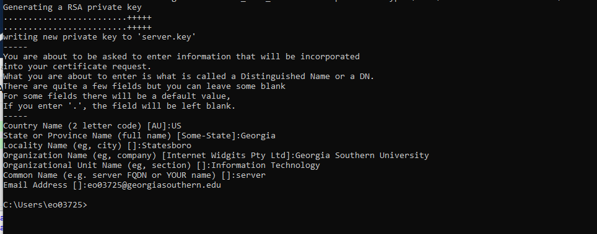
The above command and process should have generated “.rnd”, “server.crt” and “server.key” files under your user director, e.g. “C:\Users\your_name”. The “.rnd” file is just a file for random function when creating the key. The “server.crt” file is your self-signed digital certificate. Now open it and verify the information and paste a screenshot of the certificate information. The “server.key” file contains your private key.
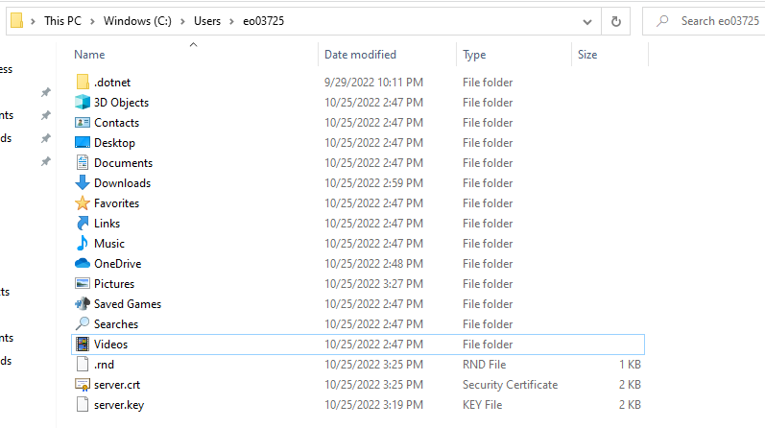
The .rnd file, server.crt and server.key are all located in the user directory.
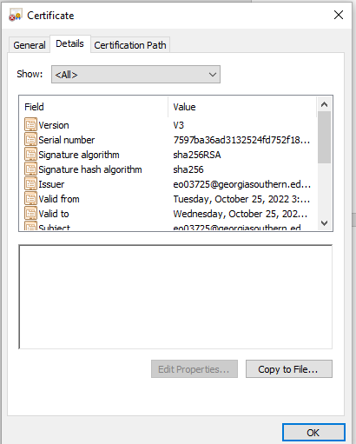
- Go to XAMPP Apache’s httpd-ssl.conf file, and search for “SSLCertificateFile” in an uncommented line. It should say SSLCertificateFile “conf/ssl.crt/server.crt”. This is by default the directory where the .crt file should be placed so that Apache can retrieve it and send it to the client’s browser when the website is visited. Now copy your server.crt file to under “C:\xampp\apache\conf\ssl.crt” directory (and overwrite the original certificate if there existed one). Paste a screenshot below showing that the certificate is placed to the correct directory.
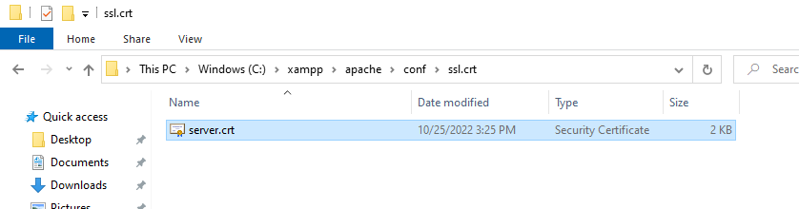
Also find “SSLCertificateKeyFile” in the httpd-ssl.conf file and it should reads SSLCertificateKeyFile “conf/ssl.key/server.key”. Copy (and overwrite) your server.key file to under the corresponding directory “C:\xampp\apache\conf\ssl.key”. Paste a screenshot below showing that the key file is placed to the correct directory.
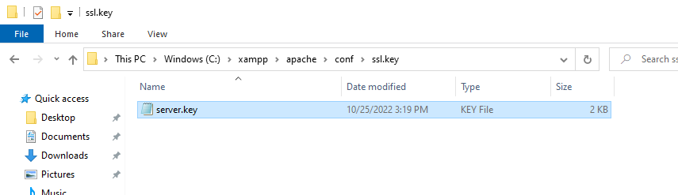
- Now test your SSL and certificate by going to “https://localhost:443” in your browser (or the port you are using for SSL/TLS). The browser should direct you to the XAMPP dashboard page. In Chrome, it may say your connection is not private. Click “Advanced” and “Proceed to localhost (unsafe)”. In IE, click “Continue to this website (not recommended)”. In both cases, you should see the URL/pad lock has something wrong showing problem with certificate being invalid or not verified. This is because your certificate is self-signed and the Certificate Authority (CA, yourself in this case) is not recognized by browser. However, your TLS/SSL and encryption should be working (just like the banks’ website). Go to the details of the certificate in your browser. Paste a screenshot below showing that you can read the certificate information in your browser.

